DOMINO: as simple as a booster, as efficient as an ejector.

The DOMINO system by Eliwell is the most compact, modular, simple and reliable solution to control transcritical CO2 refrigeration systems.

The DOMINO series of controllers by Eliwell are highly innovative and ideal for cold control in the preservation industry and particularly in supermarkets where keeping food fresh is vital.

With DOMINO, Eliwell achieves the same energy efficiency as an ejector, without having to use one. The system is thus much simpler, in other words: easy to install, to configure, to control and to service, with an evident lower initial investment and subsequent operating costs.

The compressor rack controlled using the DOMINO solution in fact ensures a significant reduction in electricity consumption; the adaptive energy-saving algorithms for the control of refrigerated cabinets guarantee the performance of the entire system reaches the utmost levels.

The DOMINO series can also be integrated with Eliwell's supervision system conceived to maintain high system efficiency over time, thereby complying with HACCP regulations on food safety.

“We continue to monitor a market that is becoming more complex by the day, in an attempt to anticipate the answers" – points out Sandro Battagli, general manager of Eliwell – "We are supported by an international research team, and we test our solutions in a real system simulator. The challenge we face is that of offering increasingly higher performance levels, through the development of technologies that simplify both new systems as well as retrofit installations.”

The core of the ejector-less solution is the **DOMINO EWCM 9000 PRO /CO2T** controller for compressor racks that makes it possible to operate with an average pressure of up to 32 bar, in combination with the new **DOMINO RTX 600 /V** electronic controllers, which feature adaptive superheat control for refrigerated cabinets.

The combination of these two products - DOMINO EWCM 9000 PRO /CO2T and DOMINO RTX 600/V - guarantees the same performance levels as an ejector solution with a much simpler booster circuit.

The possibility of raising the operating pressure by more than 30% entails a rise in energy efficiency of approximately 3 percentage points for every bar of rising pressure; thereby effortlessly exceeding 10-15% energy savings.

**Let's take a look at a typical application where Eliwell's DOMINO solutions have made the difference.**

Browsing through our case histories, we have deliberately picked out a medium-sized system, a 1,200 square-metre supermarket with 9 refrigerated cabinets and a cold room at a positive temperature, and 3 refrigerated cabinets and a cold room for the frozen line at a negative temperature. The transcritical CO2 booster compressor rack consists of 3 compressors for the positive temperature and 2 compressors for the negative temperature. The electronic control is extremely compact since the main **DOMINO EWCM 9000 PRO /CO2T** unit alone is sufficient.

We are in Switzerland, not far from the CO2 efficiency equator, on a system with a transcritical circuit where the DOMINO system has made it possible to raise the pressure from 22 to 30 bar, quickly saving more than 10% in energy efficiency. The possibility of raising the pressure further, up to 32 bar, could lead to at least four more percentage points of optimised consumption, ensuring maximum efficiency and sustainability of the solution, but most of all top-quality preservation.

Last but not least, let's see the advantages that the DOMINO solution offers to professionals along the entire supply chain.

For installers, it means using a reduced number of components: quick to set up, safe and definitely reliable. The DOMINO solution is also the most compact on the market for controlling transcritical CO2 booster racks and with parallel compression, taking up 60% less space in the panel. It is easy to configure and use, thanks to the integrated user interface, with dedicated menus for each individual system section.

For the installer, therefore, not only does the latter have better devices to control the temperature, but also the most innovative systems engineering solutions from a major international group such as Schneider Electric for whom Eliwell constitutes the core of expertise. Indeed, DOMINO integrates and liaises with **Schneider Electric EcoStruxure** enterprise and building control solutions, thereby optimising energy consumption levels in all systems.

For the System Integrators, this means new opportunities, mainly for the multiple customisation possibilities afforded by the EWCM 9000 PRO-HF model, which is completely programmable, adaptable and customisable with PLC IEC 61131 languages. The **FREE Studio** development tool allows for all the controller's maximum performance to be taken advantage of, re-configuring the I/O and making the most of the vast field connectivity and that of the system found on the controller. With the basic library supplied with the device, with debugging, simulation and diagnostics procedures, which can also be used remotely, development times have been cut drastically. In addition, DOMINO can be connected to both the **Eliwell TelevisGo** supervision system as well as to BMS Modbus/RTU and Modbus/TCP systems that allow remote control and intervention.

For the end users, the true benefits are energy savings and a complete and reliable solution with top-quality components. What's more, it is a solution that is easy to understand and use.

By choosing Eliwell and Schneider Electric, you'll find the support of a company capable of listening to and liaising with its customers, providing customised solutions to accommodate specific requirements.

We offer:  
The end user the ability to understand their needs and turn them into integrated solutions; the installer simplicity of installation and configuration; the system integrator the ability to answer the most complex customisation requests and, last but not least, the ability to support the entire supply chain with highly skilled, experienced engineers who undergo ongoing training and refresher courses.

**Eliwell constitutes the core of expertise for refrigeration and air conditioning of the Schneider Electric group**, the global automation and energy management specialist.

****[**www.eliwell.com**](http://www.eliwell.com/)

*An extensive range of air conditioning solutions.*

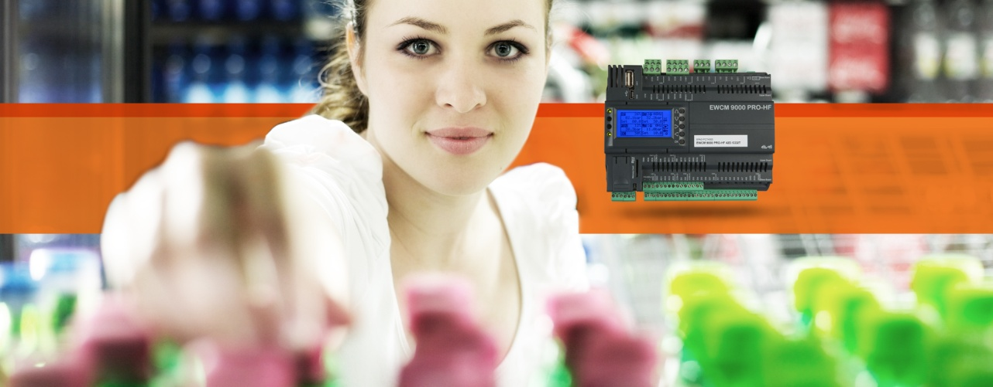

*The DOMINO RTX600/V and EWCM 9000 Pro range*

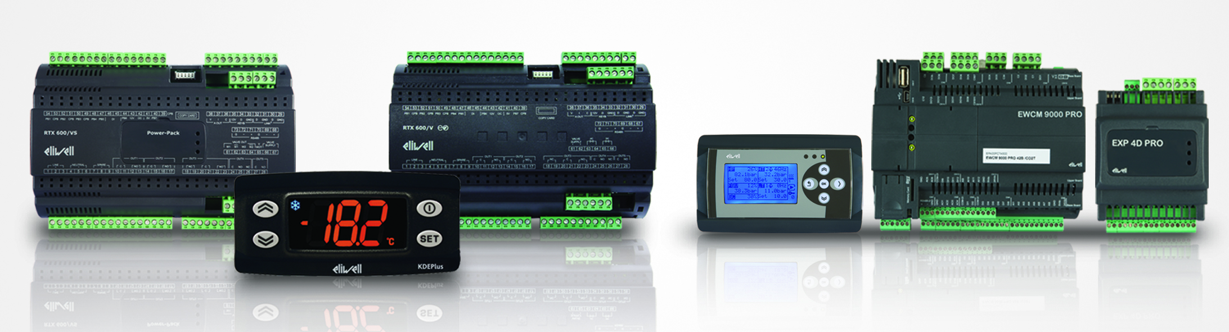

About Eliwell

Eliwell has been making control systems and services for commercial and industrial refrigeration and air conditioning units for more than 35 years, offering highly innovative and technologically advanced products. Eliwell is a company of the Schneider Electric Group. Subscribe to our newsletter at: [www.eliwell.com](http://www.eliwell.com/)

About Schneider Electric

Schneider Electric is the global automation and energy management specialist. With a turnover of approximately 25 billion euro in FY2016, our more than 144,000 employees serve customers in over one hundred countries, helping them manage their energy and their processes in a safe, reliable, efficient and sustainable manner. From a simple switch to a complex management system, our technology, our software and our services improve the way our customers manage and automate their activities. Our connected technologies are restyling industries, transforming cities and making our lives better.

At Schneider Electric, we refer to all this as Life Is On.

[www.schneider-electric.com](http://www.schneider-electric.com/)

