New additions to the Coldface range of certified controllers and switchboards for cold rooms

**Eliwell launches the new EWRC (5000 NT, 5010 NT and 5030 NT) models and extends the Coldface range to make it one of the most complete, efficient cold room control solutions.**

A top-level solution that combines the famed experience and quality intrinsic to Eliwell products with the outstanding performance of Schneider Electric power equipment; a technology development synergy that is becoming more and more successful.

**All Coldface range products** are tested and certified by external laboratories, in accordance with the European directives on electric switchboards - EN378, specifically 61.140 and 60.204 - to offer high quality, exceptionally safe solutions complete with compliance documentation.

Eliwell Coldface switchboards are supplied on a turnkey basis, complete in both single-phase and three-phase configurations, and are compatible with Eliwell's TelevisGo and TelevisBlue supervision systems, but also with third-party systems using the Modbus protocol.

They are much easier to install, especially in the systems of butchers, delicatessens, restaurants, hotels, dairies, pasta-makers, wineries, cold stores, distribution centres, and greengrocers.

Eliwell has drawn on its experience to develop a wide range where everyone will find the ideal solution for their needs. From the EWRC 300-500 NT models, for the control of small cold rooms with single-phase loads with power up to 2 Hp, to the new EWRC 5000 NT models specifically for cold rooms with three-phase loads and power consumption of up to 20 A, with 12 kW for the defrost heaters. All assisted by complete control of auxiliary loads such as fans, pump-down valve, light, compressor oil heater and alarm.

The large Coldface enclosure, in flame retardant PC+ABS, has extremely functional design able to accommodate a controller with a large two-line display and also to conveniently house all the electromechanical devices necessary for complete control of cold rooms.

The large internal volume is able to accommodate up to 15 DIN modules in the **EWRC 5000 NT** models.  
Commissioning is even faster thanks to the optimised layout of the electrical connections, supported by handy spring-clamp connectors.  
A convenient front door for direct access to the magnetothermal switches and motor protection device, and an **integrated seal to protect the controller from water splashes,** which simplifies in-depth cleaning of the installation.

The new user interface and facilitated access to the most frequently used parameters make this system even easier to configure and use.  
What's more, adoption of a large LED display, with integrated icons, enables the user to keep an eye on operation at all times**.** The internal clock, yearly calendar and alarm event logging are particularly useful when applying the HACCP health and hygiene protocol.

Coldface switchboards are the outcome of a multi-annual development plan which began with the introduction of the NT series in 2014, which involved the complete redesign of the switchboard. The project **includes additional development reaching beyond mere control of the cold room and extending to humidity control functions and the adoption of advanced energy efficiency algorithms**.

To support this range of certified switchboards, Eliwell and Schneider Electric offer **an efficient worldwide technical support network to assist engineers and technicians from the very earliest design phases.**

*Coldface, cold room control solution.*

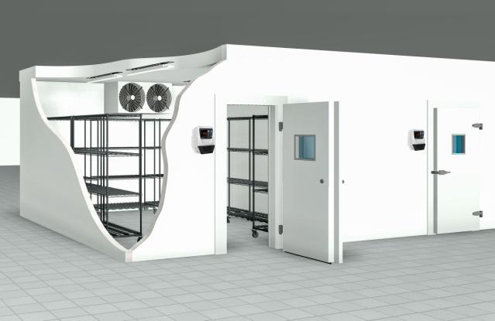

*The new range of Coldface cold room switchboards. 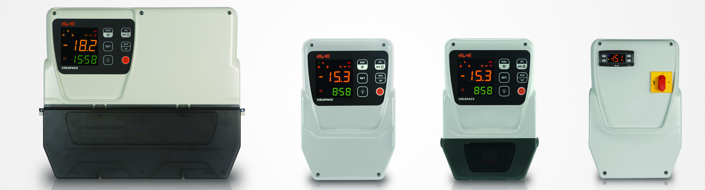*

About Eliwell

Eliwell has been making control systems and services for commercial and industrial refrigeration and air conditioning units for more than 35 years, offering highly innovative and technologically advanced products. Eliwell is a company of the Schneider Electric Group. Subscribe to our newsletter at: [www.eliwell.com](http://www.eliwell.com/)

About Schneider Electric

Schneider Electric is the global automation and energy management specialist. With a turnover of approximately 25 billion euro in FY2016, our more than 144,000 employees serve customers in over one hundred countries, helping them manage their energy and their processes in a safe, reliable, efficient and sustainable manner. From a simple switch to a complex management system, our technology, our software and our services improve the way our customers manage and automate their activities. Our connected technologies are restyling industries, transforming cities and making our lives better.

At Schneider Electric, we refer to all this as Life Is On.

[www.schneider-electric.com](http://www.schneider-electric.com/)

